Volume 4 Issue 5 May 2024

The Beacon
Beloved, let us love one another because love is from God; everyone who loves is born of God and knows God. ⁸ Whoever does not love does not know God, for God is love. 1 John 4:7-8

George Herbert
George Herbert was an English poet, orator, and priest of the Church of England. His poetry is associated with the writings of metaphysical poets, and he is recognized as "one of the foremost British devotional lyricists." Born: April 3, 1593, Died: March 1, 1633
Easter Wings
Lord, Who createdst man in wealth and store,
Though foolishly he lost the same,
Decaying more and more,
Till he became
Most poore:

With Thee
O let me rise,
As larks, harmoniously,
And sing this day Thy victories:
Then shall the fall further the flight in me.

My tender age in sorrow did beginne;
And still with sicknesses and shame
Thou didst so punish sinne,
That I became
Most thinne.

With Thee
Let me combine,
And feel this day Thy victorie;
For, if I imp my wing on Thine,
Affliction shall advance the flight in me.

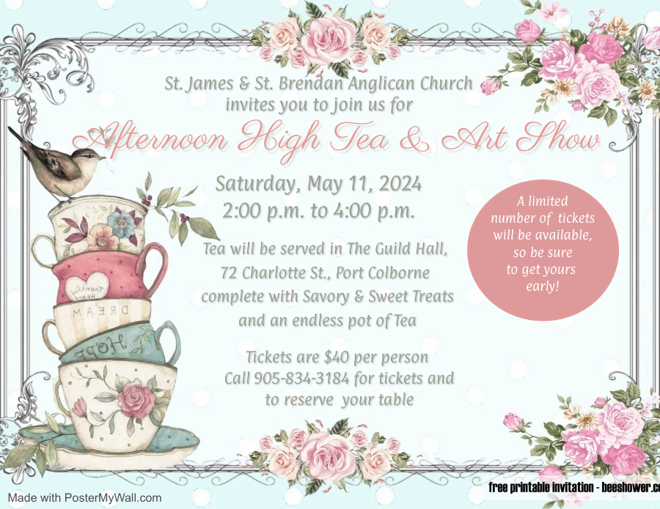
Tickets are now all sale. Come get yours before we sell out.

Saturday, June 29th, 20 - 24 Berries and Bubbly

Friday, August 16^{th,} 2024 - 3rd Annual St. J & B Golf Tournament

After much prayer and discussion with Church Leaders, it has been decided that Food with Friends will take a summer break. This program, prior to the Pandemic, only ran from October to April. Since March 2020, all the volunteers have been running for the past 4 years, 52 weeks of the year, non-stop, with no breaks. Everyone in the community is incredibly grateful for all the hard work our church and the churches in the community have done over the past few years; however, we also need a break, and we also need to replenish our Food with Friends Bank Account. Over the past few years, as you know, the cost of groceries has gone up incredibly. We went from spending on average $800 a month to on average $1300-$1500 a month. Over the summer respite, we will also be looking for new sponsors and community partners that can help the cause. If you know of anyone who would like to help fund this incredibly vital program, please let Nicole Ebert know, as she is the Coordinator of the Program.

Thank you.

Question 1
In which year did the Book of Common Prayer first come into use?
- 1560
- 1549
- 1534
- 1558

Questions 2
Who compiled the Book of Common Prayer?
- Thomas Cranmer
- Henry VIII
- Edward VI
- A committee of bishops of the Church of England

QUESTION 3:
How many liturgies for worship are there in the Book of Common Prayer?
- 21
- 16
- 10
- 9

Answer at the end of the Beacon.

Planning Ahead
In June of 2026, we will be having a 20th Anniversary Celebration of the Community of St. James and St. Brendan. In preparation for this wonderful celebration, we are asking you to dig through all your photo boxes and find any photos you may have of all 3 communities.
St. James
St. Brendan
St. James and St. Brendan.

We will keep you posted when you have more information. Thank you for your help and cooperation for this great celebration!

Church Chuckle
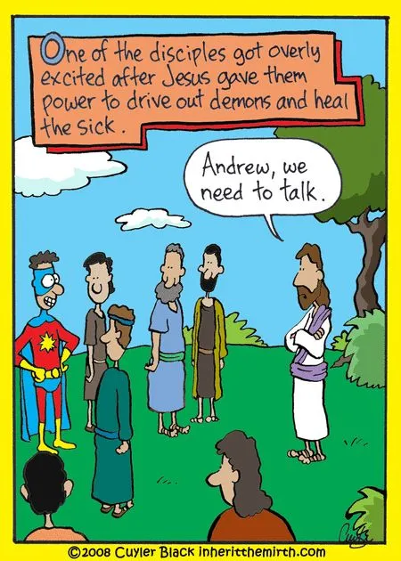

If you are unable to attend Service, nor do you have internet, please listen to the Gospel and the Sermon on your Phone.

A Gentle Reminder
Especially when you come to any service.
We ask that you be fragrance-free.

A variety of people have allergies, and we wish for everyone to be able to enjoy the Service. Your cooperation is greatly appreciated.

Answer to the Quiz Questions

QUESTION 1: IN WHICH YEAR DID THE BOOK OF COMMON PRAYER FIRST COME INTO USE IN THE CHURCH OF ENGLAND?

When England broke with the Roman Catholic Church in 1533, Henry VIII commissioned Thomas Cranmer, the Archbishop of Canterbury, to create and English language book for use in the Church of England liturgy. Cranmer’s first effort in 1534 was a fairly conservative effort, still very Catholic in form, and was merely a translation from Latin into English of books already in use (Cranmer could be accused of plagiarism!) In 1539, after meeting with a Lutheran embassy, Cranmer produced the first original English-language book, the Exhortation and Litany, for use in the Church of England. Henry VIII was not impressed with the book – it was too Protestant for his taste – and sent Cranmer back to the drawing board. Henry died in 1547, and it was under the aegis of the boy king Edward VI that Cranmer’s masterpiece, the Book of Common Prayer, was produced.

QUESTION 2: WHO COMPILED THE BOOK OF COMMON PRAYER?
As you can see from the answer to question 1, the palm goes to Thomas Cranmer. It may come as something of a surprise to most Anglicans that the BCP (that’s Anglican shorthand for the Book of Common Prayer) is not an entirely original work. Cranmer drew from several different sources; the Roman Catholic Missal forms the basis for the liturgy for Holy Communion, and the Roman Catholic Manual for Occasional Services provides the bulk of the liturgies for Baptism, Marriage and Burial Morning Prayer, Evening Prayer and Compline are all drawn from the Monastic Offices. Cranmer used The Pontifical as the source for those liturgical offices presided over by a bishop, i.e. Confirmation and Ordination. All other liturgies in the BCP are based on the Sarum Rite, which was widely used in southern England, the most heavily populated region of England. The revised edition of the BCP that Cranmer produced in 1552 shows the influence that the German reformer Martin Bucer, the Italian reformer Peter Martyr, and even his own chaplain, Thomas Becon, had on Cranmer’s churchmanship and theological understanding.

QUESTION 3: HOW MANY LITURGIES FOR USE IN WORSHIP ARE THERE IN THE BCP?
If you checked off 21, you’re right! The Book of Common Prayer includes liturgies for all services, with special liturgies for the High and Holy Days like Ash Wednesday and Good Friday. The BCP covers all stages of Anglican life, from the cradle to the grave. In addition to liturgies for use in worship, the BCP contains a complete psalter, readings for every Sunday of the year and for the aforementioned High and Holy Days, a Calendar of Saints, a Table of Kindred and Affinity (so that one knows which family member one may legally marry), a Catechism, the 39 Articles of Faith, prayers for private use, graces to be said before meals, and so on. The BCP contains three creeds. The Apostles’ Creed is ordered for use at Morning and Evening Prayer; the Nicene Creed is to be used during the liturgy for Holy Communion and on High and Holy Days, and the Creed of St. Athanasius. The latter is rarely used these days, but if you have trouble sleeping, you’ll find that it’s a dandy soporific!

Everyone is Welcome to All Our Services

Tuesday Morning Prayer
9:00 a.m.

Thursday Morning Healing Eucharist
10:00 a.m.

Bible Study
Every Thursday Morning
10:30 a.m.

Sunday Eucharist
8:30 a.m. & 10:30 a.m. September to June
9:30 a.m. July and August

Taize
Third Sunday of the Month
The next Service is May 19th, 2024.
Followed by a Pizza and Wine in the Guild Hall

Praise and Worship Service
Fourth Sunday of every month.
The next Service is on May 26th, 2024.

At the Pub with God
Fourth Sunday of every month after the Praise and Worship Service at the Belmont @ 5:15 p.m.
May 26th, 2024

Service for Peace
The next Service is on Wednesday, May 29th, 2024.
12:15pm

God Answers Prayers (G.A.P.)
Wednesday, May 15th, 2024
In the St. Brendan’s Chapel
10:00 a.m.

Places to Find Us:
https://www.portcolborneanglican.org/
Facebook:
https://www.facebook.com/stjamesandstbrendan/
YouTube:
https://www.youtube.com/c/StJamesandStBrendanAnglicanChurch
Instagram
stjamesandstbrendan

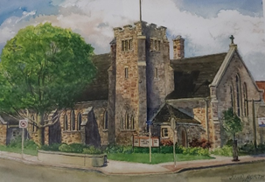
St. James and St. Brendan Anglican Church
55 Charlotte St.
Port Colborne, Ontario L3K 3C9
Phone: 905-834-3184
Email: anglicanoffice@gmail.com

If you ever have any questions or concerns, please feel free to contact anyone on the Corporation.
Rector: Rev. Jody Szoke
905-414-4860
rectorstjamesandstbrendan@gmail.com
The Corporation
Warden: John Hogan
Warden: Kathy Kairies
Deputy Warden: Colin Dennis
Deputy Warden: Jennifer Main

Vision Statement:
To Live as Christ Lived, Loving Everyone!

Mission Statement:
To invite, welcome, educate, and support people into the Community of St. James and St. Brendan and into the Life of Christ.

